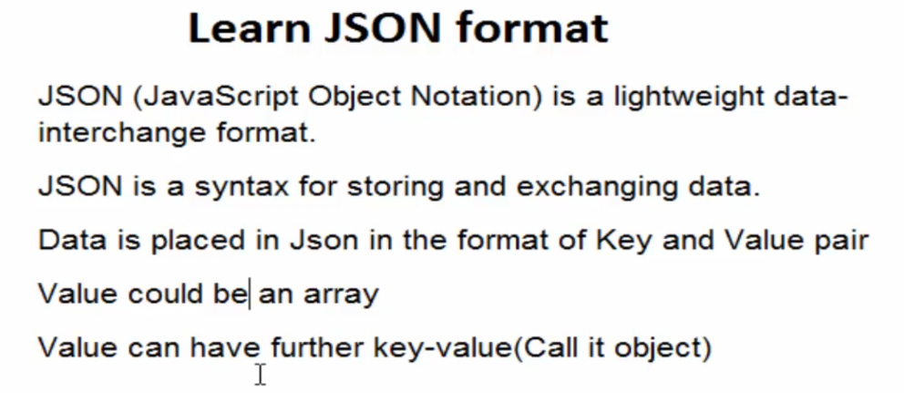

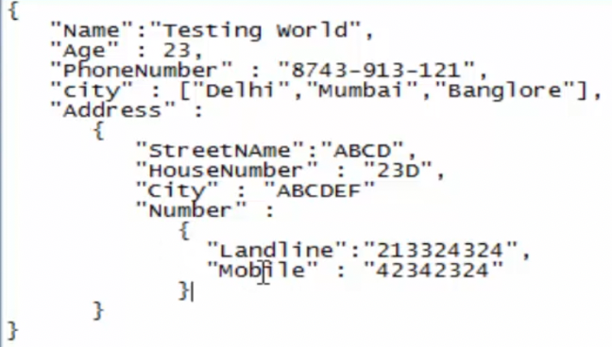

📚

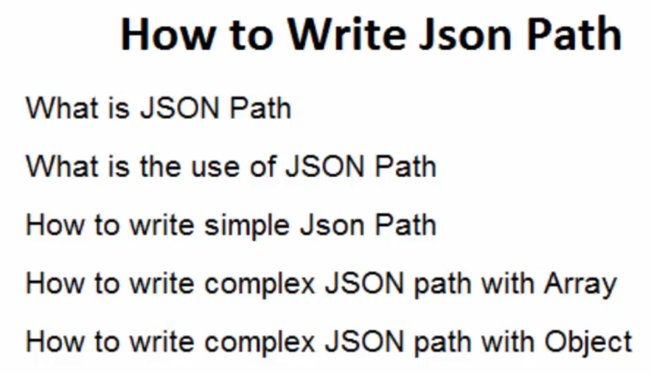

### 📚 ***** ***** ***** Website for practice ***** ***** *****

### JSONPath Online Evaluator - jsonpath.com : <https://jsonpath.com/>

### JSONPath Syntax

### $.phoneNumbers[:1].type

### ***** ***** ***** ***** ***** *****

### 

### 📚

### 

### 

### 

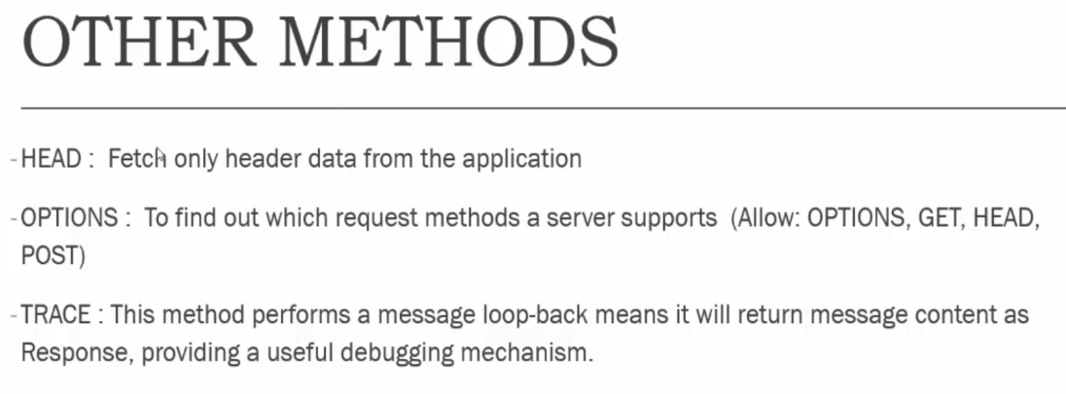

📚

<https://www.omdbapi.com/>

⚠️ The OMDb API is a RESTful web service to obtain movie information, all content and images on the site are contributed and maintained by our users.



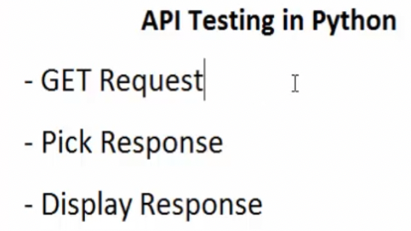

⚠️ Using this site for testing => <https://reqres.in/>

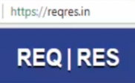

📚

⚠️ Required to install the following packages into your project: requests, jsonpath

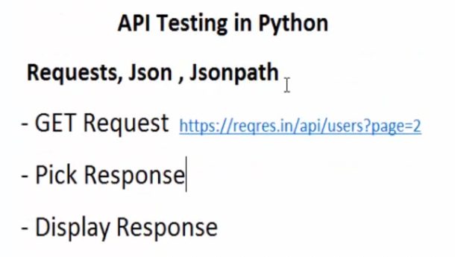

import requests  
  
# API URL  
url = "https://reqres.in/api/users?page=2"  
  
# Send Get Request  
response = requests.get(url)  
print(f"Response: => {response}\n")  
  
# Display Response Content  
print(f"Response Content: => {response.content}\n")  
print(f"Header Response: => {response.headers}")

📚

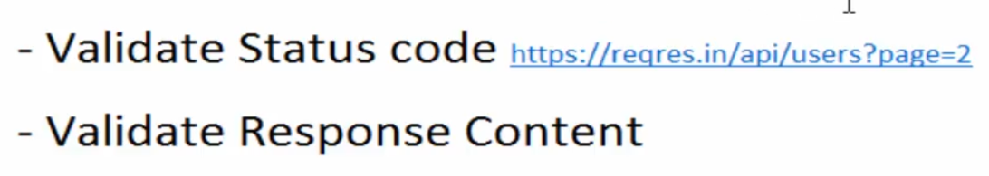

# Validate Status Code  
print(f"Status Code: => {response.status_code}")

assert response.status_code == 200

📚

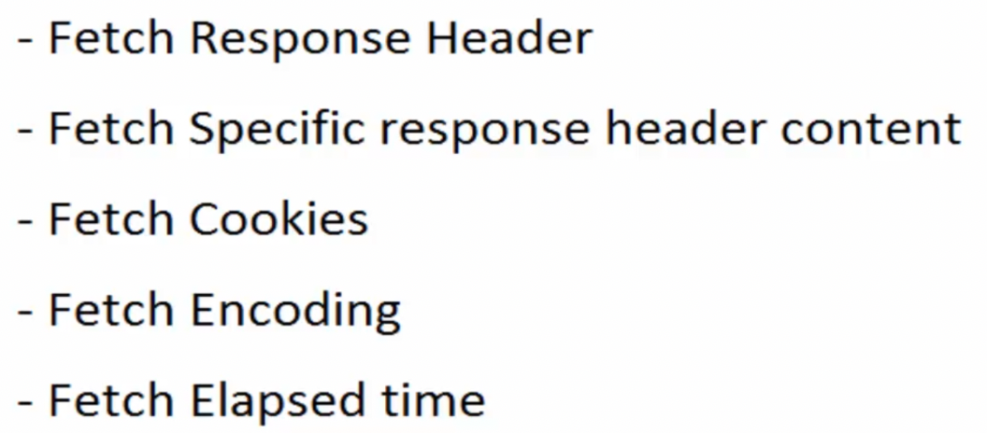

# Fetch Response Header  
print(f"Header Response: => {response.headers}")  
print(f"Date: => {response.headers.get('Date')}")  
print(f"Server: => {response.headers.get('Server')}")

# Fetch Cookies  
print(f"Fetching Cookies: => {response.cookies}")

# Fetch Encoding  
print(f"Encoding: => {response.encoding}")

# Fetch Elapsed time  
print(f"Elapsed time: => {response.elapsed}")

📚



import requests  
import json  
import jsonpath  
  
# API URL  
url = "https://reqres.in/api/users?page=2"  
  
# Send Get Request  
response = requests.get(url)  
  
# Parse response to Json format  
json_response = json.loads(response.text)  
# print(json_response)  
  
# Fetch value using Json Patch  
pages = jsonpath.jsonpath(json_response, 'total_pages')  
# print(pages[0])  
assert pages[0] == 2

📚

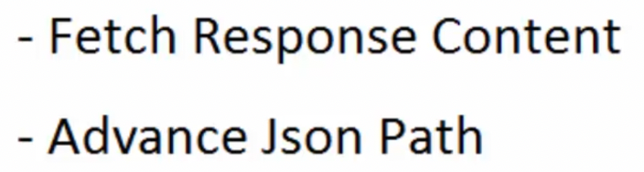

import requests  
import json  
import jsonpath  
  
# API URL  
url = “<https://reqres.in/api/users?page=2>”

# Send Get Request  
response = requests.get(url)

# Parse response to Json format  
json_response = json.loads(response.text)  
# print(json_response)

# Fetch value using Json Patch  
first_name1 = jsonpath.jsonpath(json_response, 'data[0].first_name')  
print(first_name1)  
first_name2 = jsonpath.jsonpath(json_response, 'data[2].first_name')  
print(first_name2)  
  
  
# fetching all names  
for i in range(0, 3):  
 # data[0].first_name  
 first_name = jsonpath.jsonpath(json_response, 'data[' + str(i) + '].first_name')  
 print(first_name[0])

📚

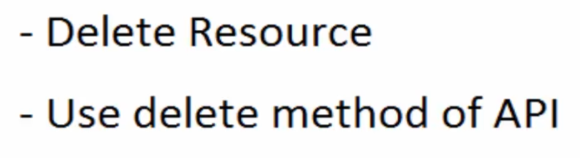

import requests  
  
# API URL  
url = "https://reqres.in/api/users/2"  
  
response = requests.delete(url)  
  
# Fetch Response code  
print(response.status_code)  
assert response.status_code == 204  
  
'''  
After deleting the user, we need to send the get request   
and verify that the user does not exist anymore.  
'''

📚

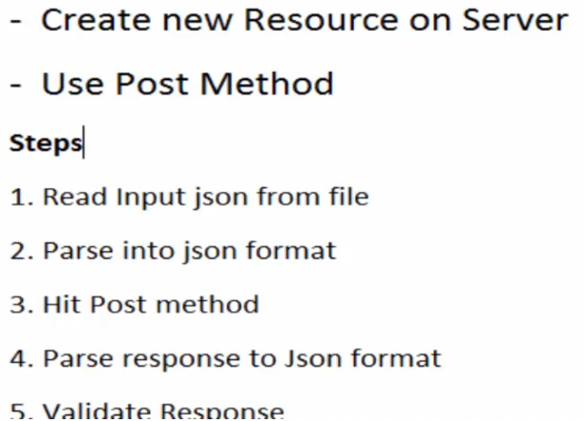

Create the < any_file_name.json > file with similar content

{  
 "name": "My Testing World",  
 "job": "QA_Engineer: qa@example.com"  
}

import json  
import requests  
  
# API URL  
url = "https://reqres.in/api/users"

# Read input json file  
file = open('createUser.json', 'r')  
json_input = file.read()  
request_json = json.loads(json_input)  
print(request_json)  
file.close()

# Make POST request with json input body  
response = requests.post(url, request_json)  
print(response.content)

import json  
import jsonpath  
import requests  
  
# API URL  
url = "https://reqres.in/api/users"  
  
# Read input json file  
file = open('createUser.json', 'r')  
json_input = file.read()  
request_json = json.loads(json_input)  
print(request_json)  
file.close()  
  
# Make POST request with json input body  
response = requests.post(url, request_json)  
# print(response.content)  
assert response.status_code == 201

# Fetch Header from Response  
print(f"Header Response: => response.headers {response.headers}")  
print("Content-Length: => " + response.headers.get('Content-Length'))

# Parse response to json format  
response_json = json.loads(response.text)

# Pick ID using json path  
item_id = jsonpath.jsonpath(response_json, 'id') # jsonpath always returns a list  
print(f"ID: => {item_id[0]}")

📚

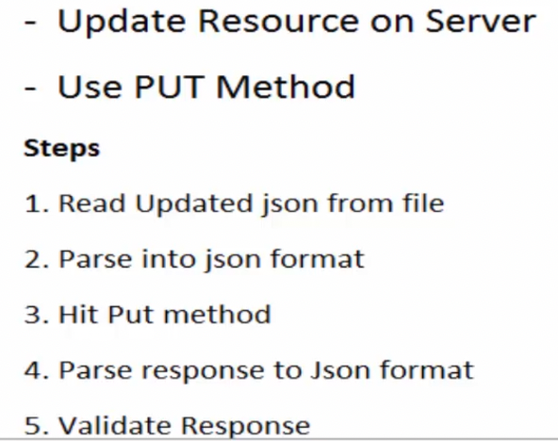

import json  
import jsonpath  
import requests  
  
# API URL  
url = "https://reqres.in/api/users/2"  
  
# Read input json file  
file = open('createUser.json', 'r')  
json_input = file.read()  
request_json = json.loads(json_input)  
# print(request_json)  
file.close()  
  
# Make PUT request with json input body  
response = requests.put(url, request_json)  
# print(response.content)  
  
# Validating Response Code  
assert response.status_code == 200  
  
# Parse response Content  
response_json = json.loads(response.text)  
print(f"Response : => {response_json}")  
updated_li = jsonpath.jsonpath(response_json, 'updatedAt')  
print(updated_li[0])

📚

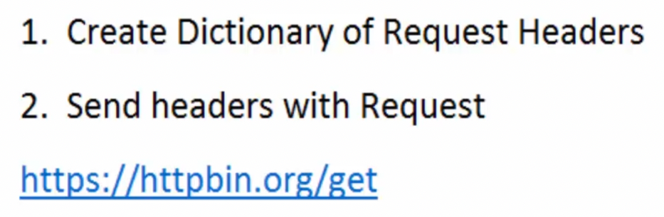

URL: "http://httpbin.org/get"

Sending Customized Headers =>

import requests

# Customized header  
header_data = {'T1': 'First_Header', 'T2': 'Second_Header'}

response = requests.get('http://httpbin.org/get', headers=header_data)

print(response.text)

''' Output:  
{  
 "args": {},   
 "headers": {  
 "Accept": "*/*",   
 "Accept-Encoding": "gzip, deflate",   
 "Host": "httpbin.org",   
 "T1": "First_Header",   
 "T2": "Second_Header",   
 "User-Agent": "python-requests/2.28.1",   
 "X-Amzn-Trace-Id": "Root=1-6328f8fe-20701f847153dd4f6eade3d2"  
 },   
 "origin": "67.180.123.128",   
 "url": "http://httpbin.org/get"  
}  
'''

📚

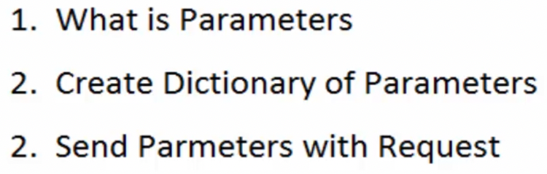

**Parameters** => Everything what is placed after the < ? > in the URI (e.g. the Question Mark) =>

“ [https://www.google.com/search?**q=testing&source=lnms&tbm=nws&sa=X&ved=2ahUKEwivq4LegqL6AhVMADQIHVuzANsQ_AUoAXoECAEQAw&biw=1883&bih=1046&dpr=**1](https://www.google.com/search?q=testing&source=lnms&tbm=nws&sa=X&ved=2ahUKEwivq4LegqL6AhVMADQIHVuzANsQ_AUoAXoECAEQAw&biw=1883&bih=1046&dpr=1) “

All parameters are separated by &

import requests  
  
param = {'name': 'testingworld', 'email': 'testingworld@example.com', 'phone': '+380-482-652310'}  
  
response = requests.get('http://httpbin.org/get', params=param)  
  
print(response.text)  
  
''' Output:  
{  
 "args": {  
 "email": "testingworld@example.com",   
 "name": "testingworld",   
 "phone": "+380-482-652310"  
 },   
 "headers": {  
 "Accept": "*/*",   
 "Accept-Encoding": "gzip, deflate",   
 "Host": "httpbin.org",   
 "User-Agent": "python-requests/2.28.1",   
 "X-Amzn-Trace-Id": "Root=1-6329035e-0c435048772f05fc20fd3d9e"  
 },   
 "origin": "67.180.123.128",   
 "url": "http://httpbin.org/get?name=testingworld&email=testingworld%40example.com&phone=%2B380-482-652310"  
'''

📚 



https://docs.pytest.org/en/7.1.x/#

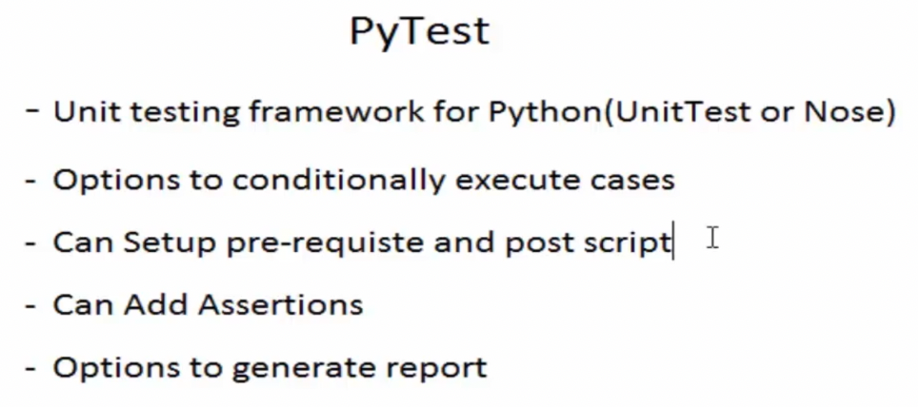

$ pip install pytest



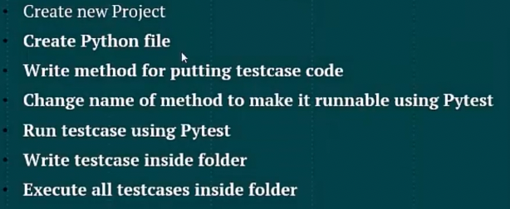

*'''  
Testcase code must be written inside a method  
Method name must be started with word "test"  
To run the script => use command: $ pytest file_name.py*

*Testcases могут быть запушены при указании директории где эти testcases находятся  
  
  
'''*def test_tc001_login_logout_testing():  
 print("this is first case...")

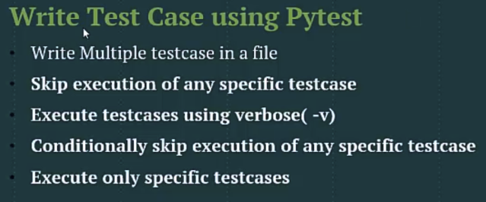

Пример запуска всего одно файла из директории:

[API_Testing]$ pytest AutomationCases/test_tc001.py

$ [API_Testing]$ pytest -v AutomationCases

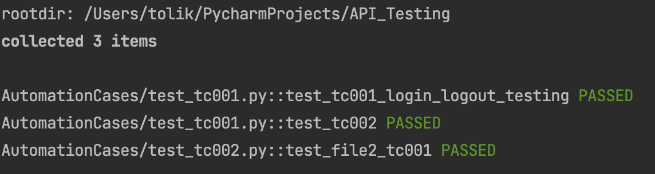

(venv) [API_Testing]$ pytest -s -v AutomationCases

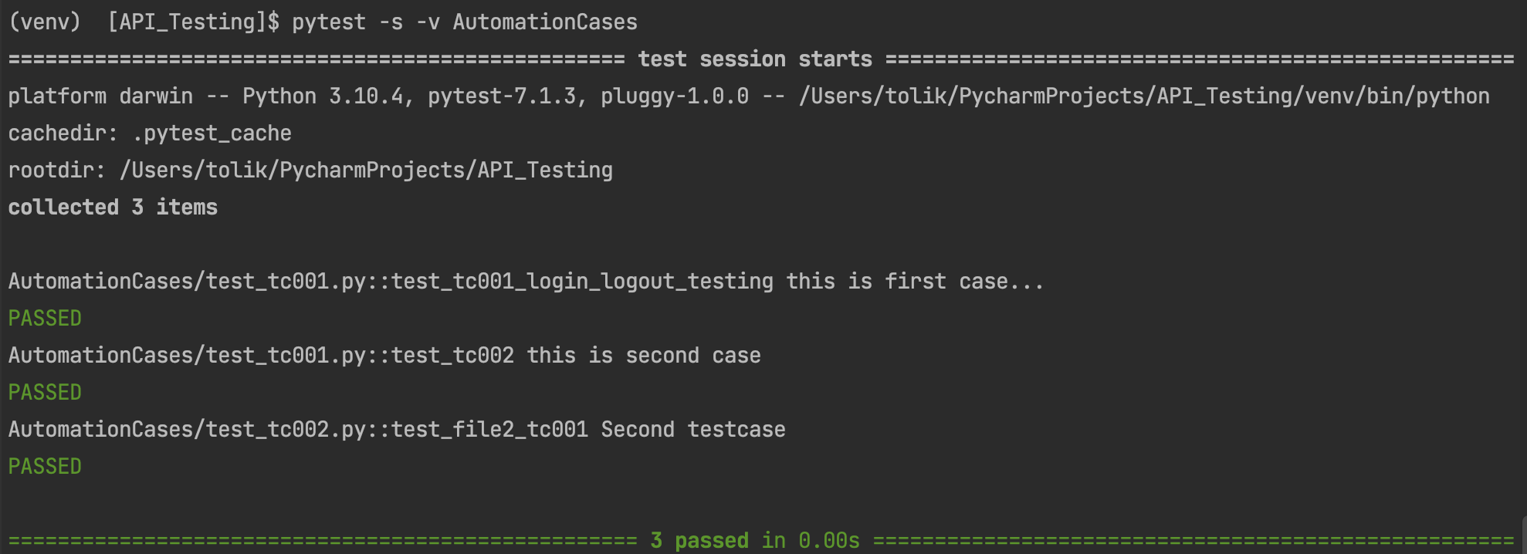

Print statement output display on console with option: ( -s )

Verbose mode – display test cases name with option: ( -v )

How to skip running testcase => @pytest.mark.skip

# Decorator  
@pytest.mark.skip("Clear Explanation Why test has been skipped")  
def test_tc002():  
 print("this is second case")

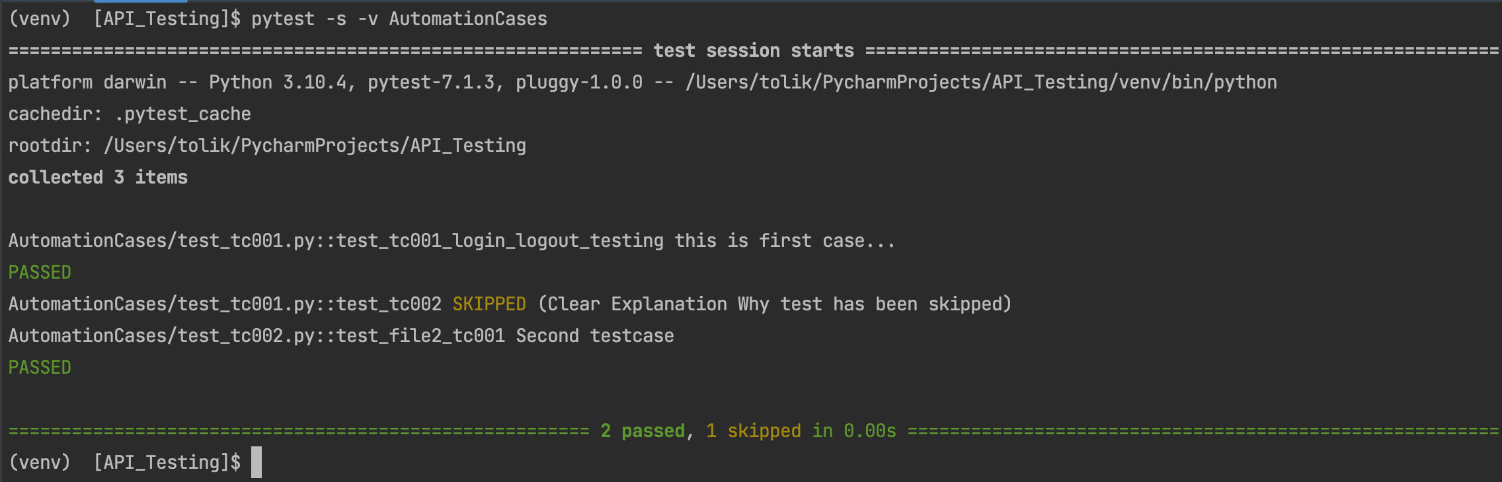

@pytest.mark.skipif

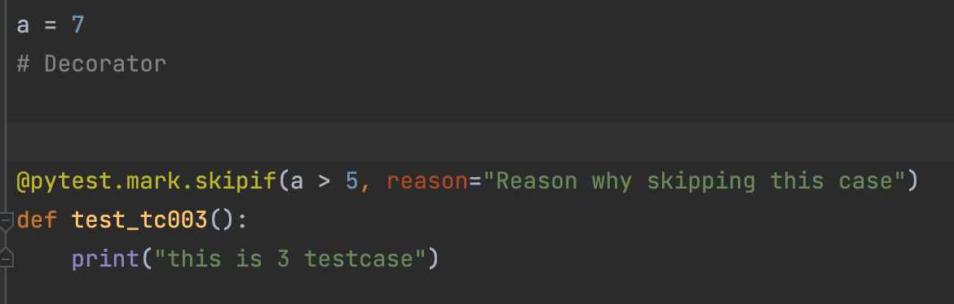

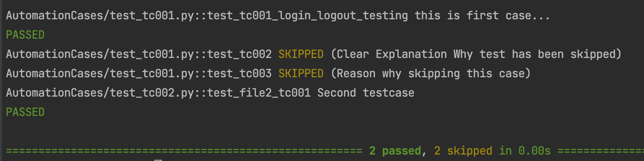

Execute only specific testcases with option => ( -k )

$ pytest -s -v -k test_tc001.py AutomationCases



Execute testcases only using partial name => $ pytest -s -v -k tc0 AutomationCases

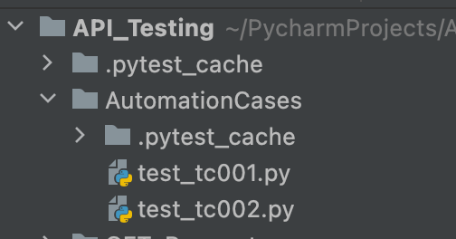



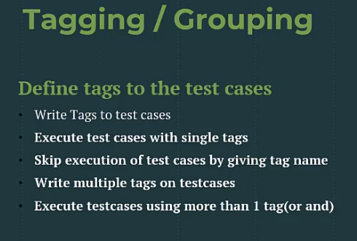

Write Tags on testcases

import pytest  
  
  
@pytest.mark.Smoke  
def test_file2_tc001():  
 print("First testcase of 2nd file")  
 print("Smoke test")  
  
  
@pytest.mark.Sanity  
def test_file2_tc002():  
 print("Second testcase of 2nd file")  
 print("Sanity test")

Execute Testcases with single option tag ( -m ) tag e.g. Smoke/Sanity

$ pytest -s -v **-m Smok**e AutomationCases

$ pytest -s -v **-m Sanity** AutomationCases

Execute all cases which are not related to Smoke =>

$ pytest -s -v -m "not Smoke" AutomationCases

We can use more than one tag name per testcase =>

@pytest.mark.Sanity  
@pytest.mark.Regression  
def test_file3_tc001():  
 print("First testcase of 3rd file")  
 print("Sanity")

@pytest.mark.Smoke  
def test_file3_tc002():  
 print("Second testcase of 3rd file")  
 print("Smoke")

Execute cases which related to one or another tag =>

$ pytest -s -v -m " Smoke or Sanity" AutomationCases

Execute testcases where more than one tag related to one testcase =>

$ pytest -s -v -m " Smoke and Regression" AutomationCases

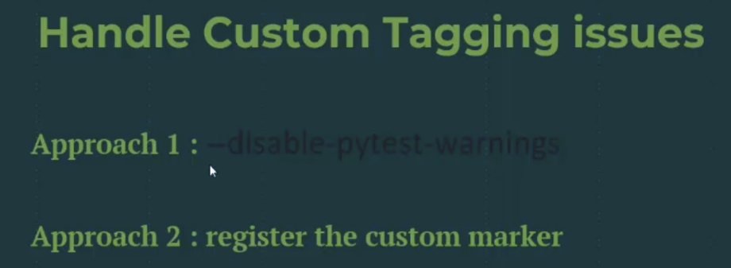

$ pytest -s -v --disable-pytest-warnings -m "Smoke or Sanity" AutomationCases

In the root of the project name create file: pytest.ini

Where we can register all custom tags

[pytest]  
markers =  
 Smoke: This is for Smoke Testcases Execution  
 Sanity: This if for Sanity Testcases Execution  
 Regression: This is for Regression Execution

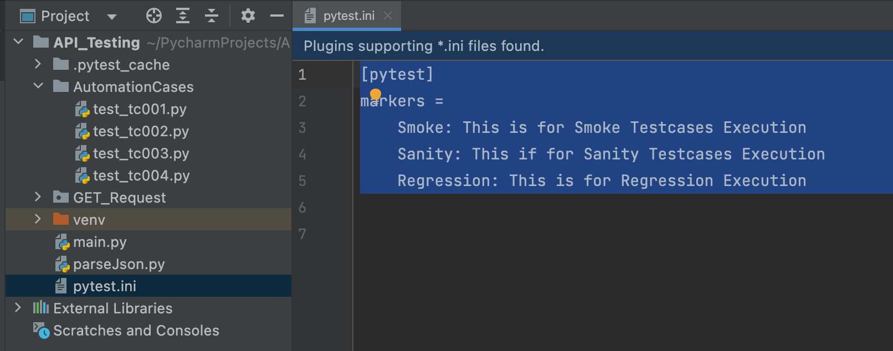

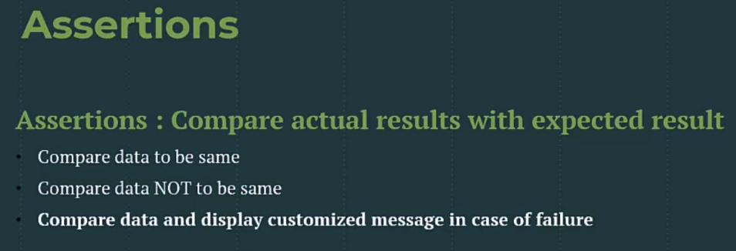

import pytest  
  
  
actual_result = 'Testing'  
  
  
@pytest.mark.Smoke  
def test_file4_tc001():  
 print("First testcase of 4th file")  
 print("Smoke test")  
 assert actual_result != 'New'  
  
  
@pytest.mark.Sanity  
def test_file4_tc002():  
 print("Second testcase of 4th file")  
 print("Sanity test")  
 assert actual_result == 'Testing'

Writing the customized message in the assert statement: =>

import pytest  
  
  
actual_result = 'Testing'  
  
  
@pytest.mark.Smoke  
def test_file4_tc001():  
 print("First testcase of 4th file")  
 print("Smoke test")  
 assert actual_result == 'New', "These 2 values not the same"

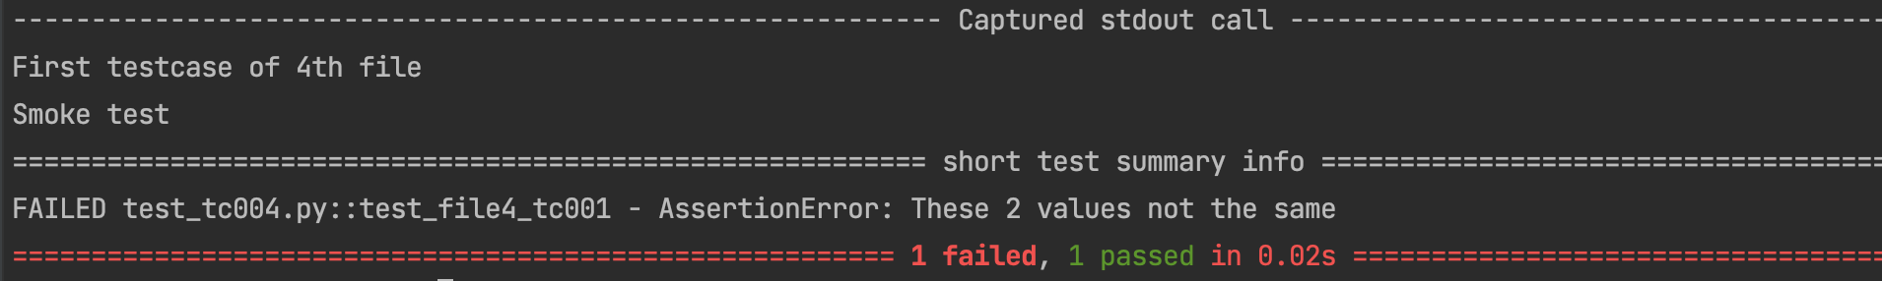



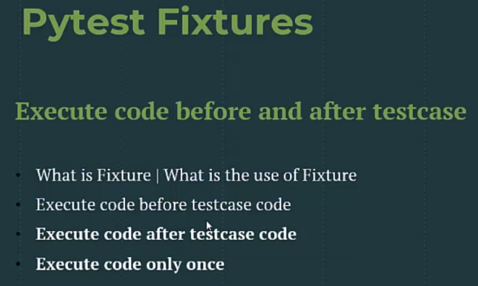

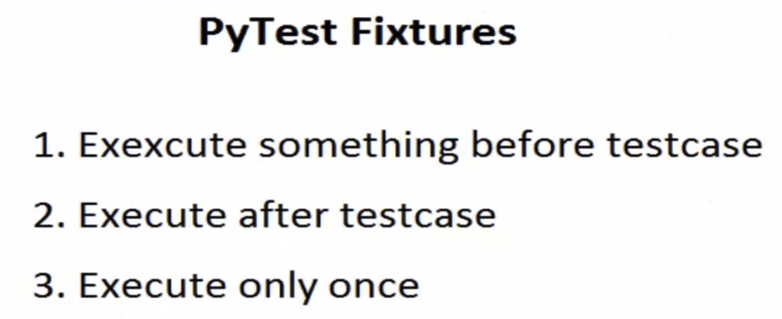

import pytest  
  
  
@pytest.fixture()  
def fixture_code():  
 print("This is our Fixture Code will execute before testcases")  
 print("============================")  
 yield  
 print("Close DB connection after executing testcase")  
 print("============================")  
  
  
@pytest.mark.Sanity  
@pytest.mark.Regression  
def test_file3_tc001(fixture_code):  
 print("First testcase of 3rd file")  
 print("Sanity")  
 print("End of the case")  
  
  
@pytest.mark.Smoke  
def test_file3_tc002(fixture_code):  
 print("Second testcase of 3rd file")  
 print("Smoke")  
 print("End of the case")

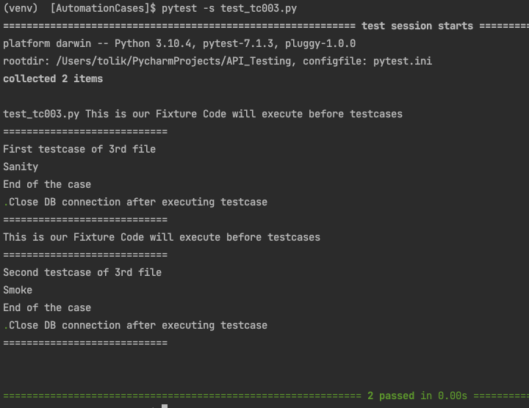

С этой опцией fixture будет выполнена в начале и закрыта после того, как все testcases пройдут проверку и в конце проверки всех файлов, будет закрыта

@pytest.fixture(scope=’module’)

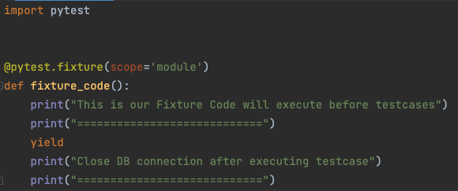

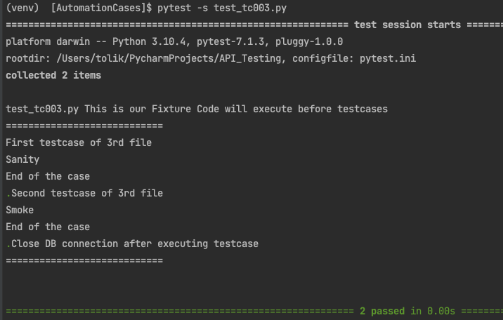

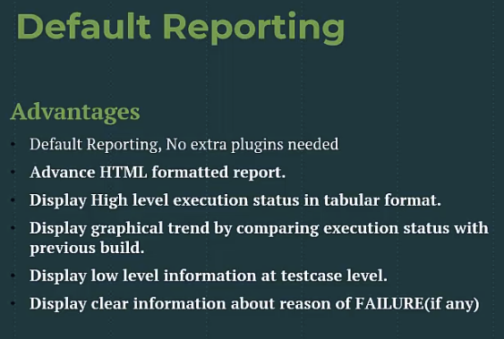

*** To view the html report, install package: pytest-html-report



Add New Student

import requests  
import json  
import jsonpath  
  
  
def test_add_student_data():  
 API_URL = "https://thetestingworldapi.com/api/studentsDetails"  
 file = open("/Users/tolik/PycharmProjects/API_Testing/TASK_API/request_json.json", 'r')  
 json_request = json.loads(file.read())  
 response = requests.post(API_URL, json_request)  
 print(response.text) # To view print statement you need to add option -s  
 # (e.g. $ pytest test_AddNewStudent.py -s)  
 file.close()

Fetch Student

def test_get_student_data():  
 API_URL = "https://thetestingworldapi.com/api/studentsDetails/3845278"  
 response = requests.get(API_URL)  
 # json_response = json.loads(response.text)  
 # OR u can wright like:  
 json_response = response.json()  
 print(f"json response => {json_response}")  
 student_id = jsonpath.jsonpath(json_response, 'data.id') # jsonpath always returns a list  
  
 print(f"Student ID: {student_id}")  
 assert student_id[0] == 3845278, "Expected value: 3845278"

Update Student

def test_update_student_data():  
 API_URL = "https://thetestingworldapi.com/api/studentsDetails/3845278"  
 file = open("/Users/tolik/PycharmProjects/API_Testing/TASK_API/request_json.json", 'r')  
 json_request = json.loads(file.read())

response = requests.put(API_URL, json_request)

print(response.text)  
 # To view print statement you need to add option -s  
 # (e.g. $ pytest test_AddNewStudent.py -s)

file.close()

# Сейчас мы должны проверить что данные обновились правильно  
  
def test_get_student_data():  
 API_URL = "https://thetestingworldapi.com/api/studentsDetails/3845278"  
 response = requests.get(API_URL)  
 # json_response = json.loads(response.text)  
 # OR u can wright like:  
 json_response = response.json()  
 print(f"json response => {json_response}")  
 student_id = jsonpath.jsonpath(json_response, 'data.id') # jsonpath always returns a list  
 print(f"Student ID: {student_id}")  
 assert student_id[0] == 3845278, "Expected value: 3845278"

Delete Student

def test_delete_student():  
 API_URL = "https://thetestingworldapi.com/api/studentsDetails/3845278"  
 response = requests.delete(API_URL)  
 print(response.text)

End to End Test Case

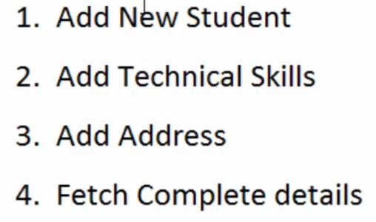

import requests  
import json  
import jsonpath  
  
  
def test_add_data():  
 app_URL = "https://thetestingworldapi.com/api/studentsDetails"  
 file = open("/Users/tolik/PycharmProjects/API_Testing/TASK_API/new_json_request.json", 'r')  
 json_request = json.loads(file.read())  
 response = requests.post(app_URL, json_request)  
 print(f"RESPONSE: {response.text}")  
 # Extracting data from response  
 student_id = jsonpath.jsonpath(response.json(), 'id')  
 first_name = jsonpath.jsonpath(response.json(), 'first_name')  
 dob = jsonpath.jsonpath(response.json(), 'date_of_birth')  
 print(f"id: {student_id}")  
 print(f"other way to get id: {student_id[0]}")  
 print(f"first name: {first_name}")  
 print(f"DOB : {dob}")  
 file.close()

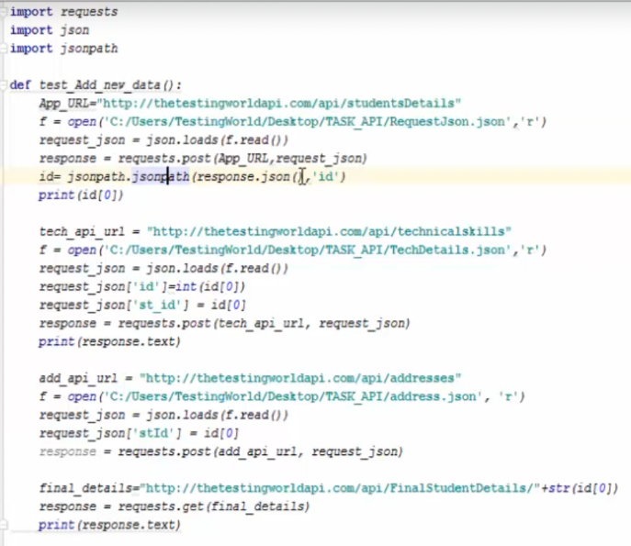

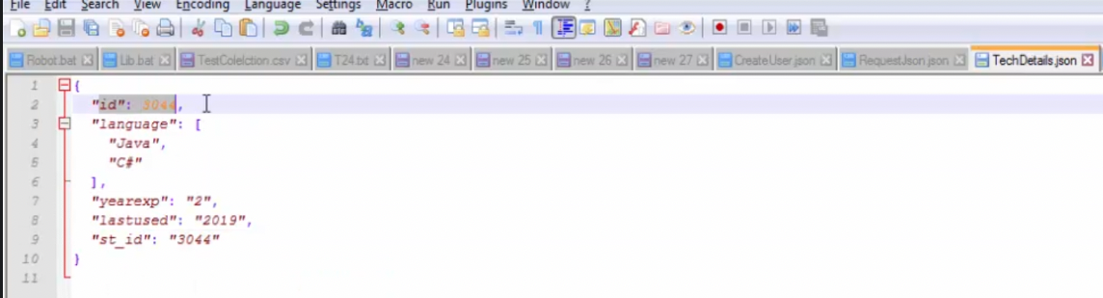

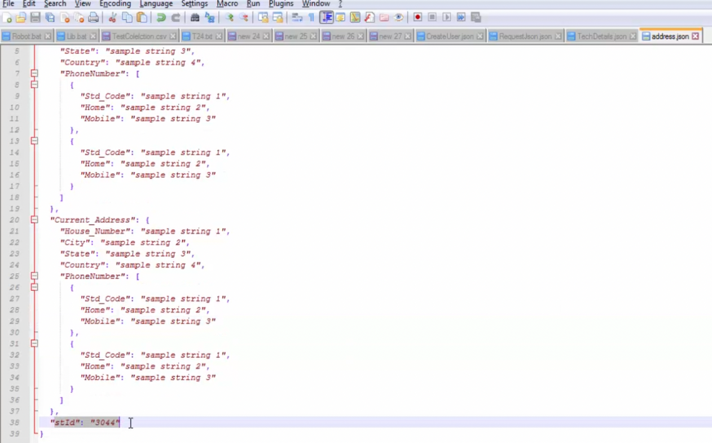

Переписать код с этого screenshot

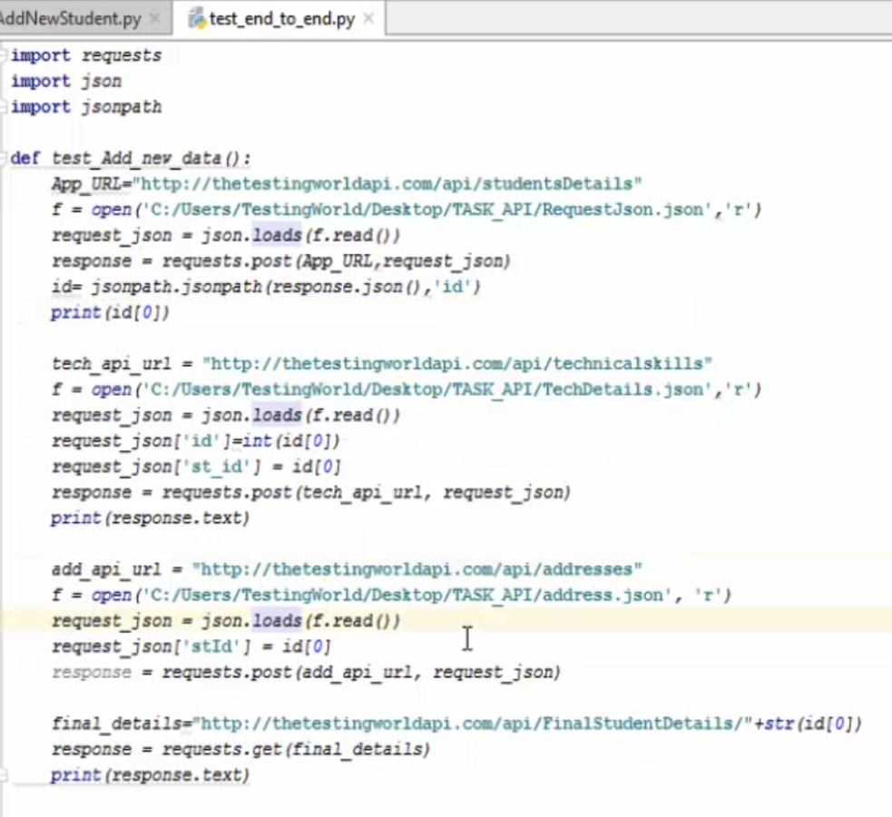

Код внизу можно удалить после написания нового. Код не рабочий

import requests  
import json  
import jsonpath  
  
  
def test_add_data():  
 base_url = "https://thetestingworldapi.com/api/studentsDetails"  
 file = open("/Users/tolik/PycharmProjects/API_Testing/TASK_API/new_json_request.json", 'r')  
 json_request = json.loads(file.read())  
 response = requests.post(base_url, json_request)  
 print(f"RESPONSE: {response.text}")  
 # Extracting data from response  
 student_id = jsonpath.jsonpath(response.json(), 'id')  
 print(f"id: {student_id}")  
 # print(f"other way to get id: {student_id[0]}")  
  
  
 tech_api_url = "https://thetestingworldapi.com/api/studentsDetails/technicalskills"  
 file = open("/Users/tolik/PycharmProjects/API_Testing/TASK_API/post_technicalSkills.json", 'r')  
 request_json = json.loads(file.read())  
 request_json['id'] = id[0]  
 request_json['st_id'] = id[0]  
 response = requests.post(tech_api_url, request_json)  
 print(f"Tech Response: {response.text}")  
  
  
 add_api_url = "https://thetestingworldapi.com/api/studentsDetails/addresses"  
 file = open("/Users/tolik/PycharmProjects/API_Testing/TASK_API/address.json", 'r')  
 request_json = json.loads(file.read())  
 response = requests.post(add_api_url, request_json)  
 print(f"Tech Response: {response.text}")  
  
  
 final_details = "https://thetestingworldapi.com/api/FinalStudentDetails/3845727"  
 response = requests.get(final_details)  
 print(response.text)  
  
 file.close()



import json  
import jsonpath  
import requests  
  
  
def test_add_new_students():  
 global id  
 base_url = "https://thetestingworldapi.com/api/studentsDetails"  
 file = open("/Users/tolik/PycharmProjects/API_Testing/TASK_API/new_json_request.json", 'r')  
 # file is open, and I want to read it in json format  
 json_request = json.loads(file.read())  
 response = requests.post(base_url, json_request)  
 # I want to fetch response  
 print(response.text)  
 # id = jsonpath.jsonpath(response.json(), 'last_name')  
 id = jsonpath.jsonpath(response.json(), 'id')  
 print(id[0])  
   
  
def test_get_details():  
 url = "https://thetestingworldapi.com/api/studentsDetails/"+str(id[0])  
 response = requests.get(url)  
 print(response.text)

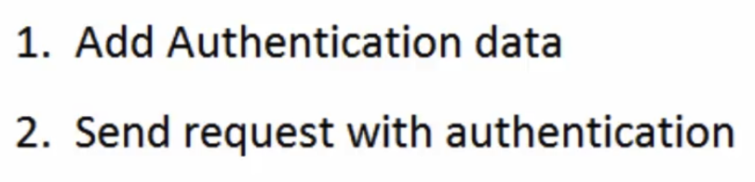

import requests  
from requests.auth import HTTPBasicAuth  
  
  
def test_with_authentication():  
 response = requests.get("https://api.github.com/user", auth=HTTPBasicAuth('user_name', 'password'))  
 print(response.text)

$ pytest test_basicAuthentication.py -s

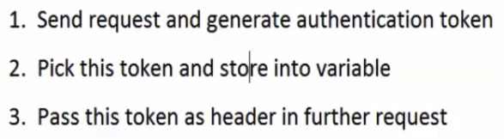

import json  
import requests  
import jsonpath  
  
  
def test_oauth_api():  
 token_url = "https://thetestingworldapi.com/Token"  
 data = {'grant_type': 'password', 'username': 'admin', 'password': 'adminpass'}  
 response = requests.post(token_url, data)  
 print(response.text)  
 token_value = jsonpath.jsonpath(response.json(), 'access_token')  
  
 auth = {'Authorization': 'Bearer ' +token_value[0]}  
 base_url = "https://thetestingworldapi.com/api/StDetails/1104"  
 response = requests.get(base_url, headers=auth)  
 print(response.text)

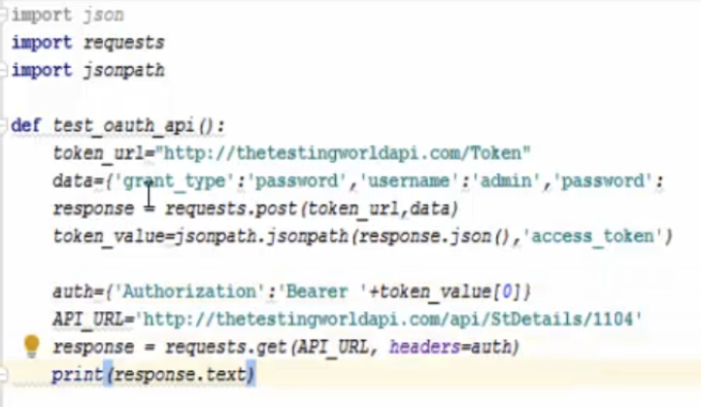

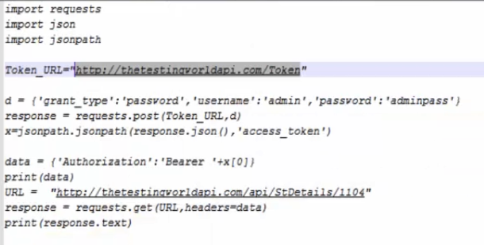



<https://thetestingworldapi.com/>

# **Web API Help Page**

<https://thetestingworldapi.com/Help>

★★★★★★★★★★★★★★★★★★★★★★★★ ★★★★★★★★★★★★★★★★★★★★★★★★

Data Driven Framework

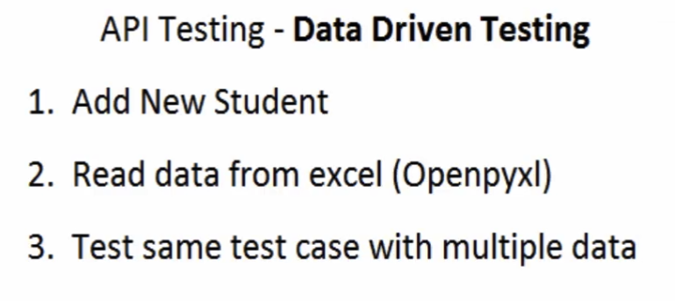

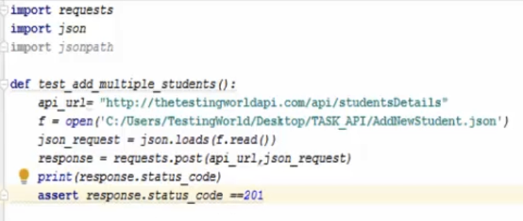

Read data from the excel file =>

$ pip3 install openpyxl

import requests  
import json  
import jsonpath  
import openpyxl  
  
  
def test_add_multiple_students_excel():  
 # API  
 base_url = "https://thetestingworldapi.com/api/studentsDetails"  
 file = open("/Users/tolik/PycharmProjects/API_Testing/TASK_API/request_json.json", 'r')  
  
 # Excel Code  
 wk = openpyxl.load_workbook("/Users/tolik/PycharmProjects/API_Testing/TASK_API/testData.xlsx")  
 sh = wk['Sheet1']  
 rows = sh.max_row  
 json_request = json.loads(file.read())  
  
 for i in range(2, rows + 1):  
 cell_first_name = sh.cell(row=i, column=1)  
 cell_mid_name = sh.cell(row=i, column=2)  
 cell_last_name = sh.cell(row=i, column=3)  
 cell_dob = sh.cell(row=i, column=4)  
  
 json_request['first_name'] = cell_first_name.value  
 json_request['middle_name'] = cell_mid_name.value  
 json_request['last_name'] = cell_last_name.value  
 json_request['date_of_birth'] = cell_dob.value  
  
 response = requests.post(base_url, json_request)  
  
 print(response.text)  
 print(response.status_code)  
 assert response.status_code == 201  
  
 file.close()

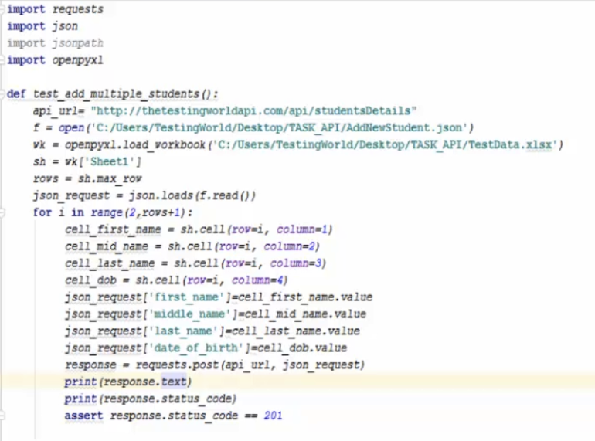

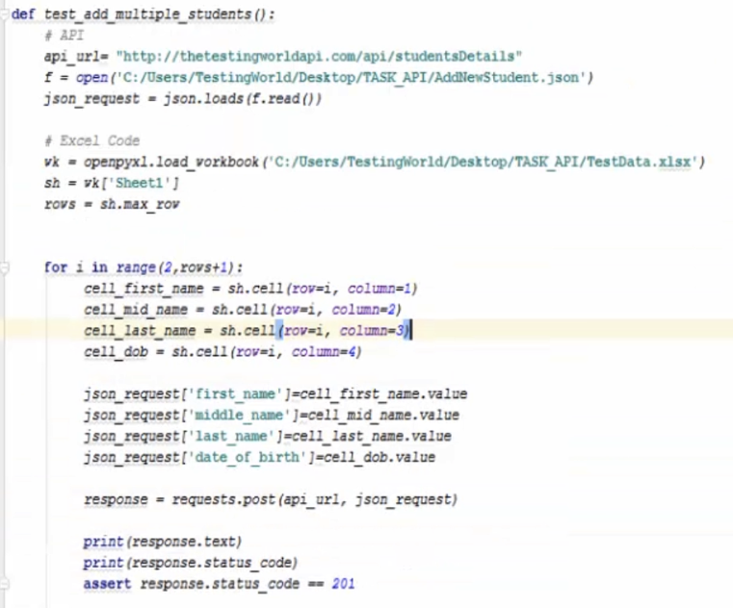

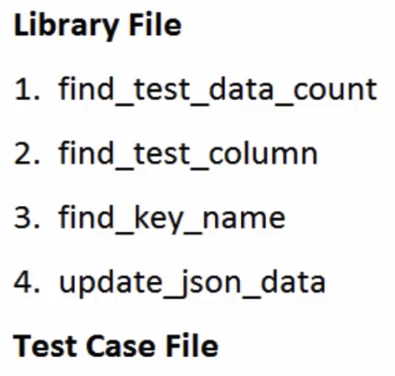

Create the DataDriven folder

Create the library.py file

Create the TestCase.py file

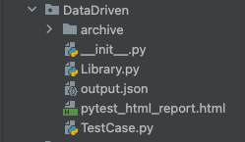

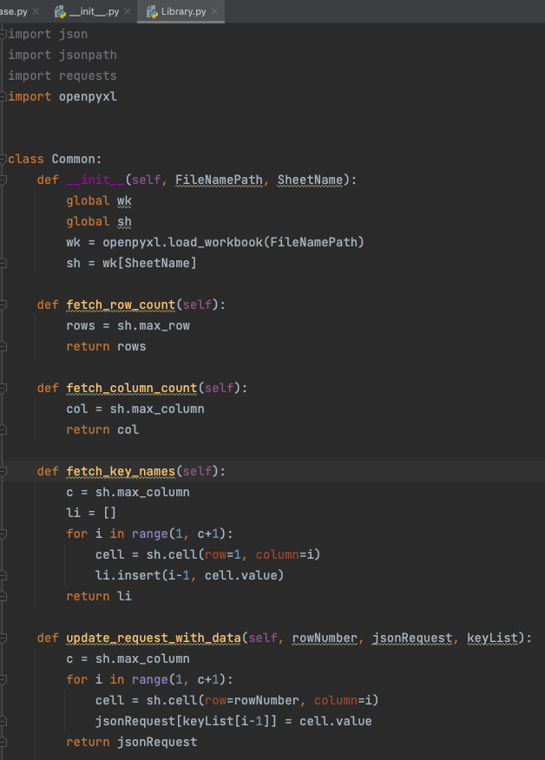

import json  
import jsonpath  
import requests  
import openpyxl  
  
  
class Common:  
 def __init__(self, FileNamePath, SheetName):  
 global wk  
 global sh  
 wk = openpyxl.load_workbook(FileNamePath)  
 sh = wk[SheetName]  
  
 def fetch_row_count(self):  
 rows = sh.max_row  
 return rows  
  
 def fetch_column_count(self):  
 col = sh.max_column  
 return col  
  
 def fetch_key_names(self):  
 c = sh.max_column  
 li = []  
 for i in range(1, c+1):  
 cell = sh.cell(row=1, column=i)  
 li.insert(i-1, cell.value)  
 return li  
  
 def update_request_with_data(self, rowNumber, jsonRequest, keyList):  
 c = sh.max_column  
 for i in range(1, c+1):  
 cell = sh.cell(row=rowNumber, column=i)  
 jsonRequest[keyList[i-1]] = cell.value  
 return jsonRequest

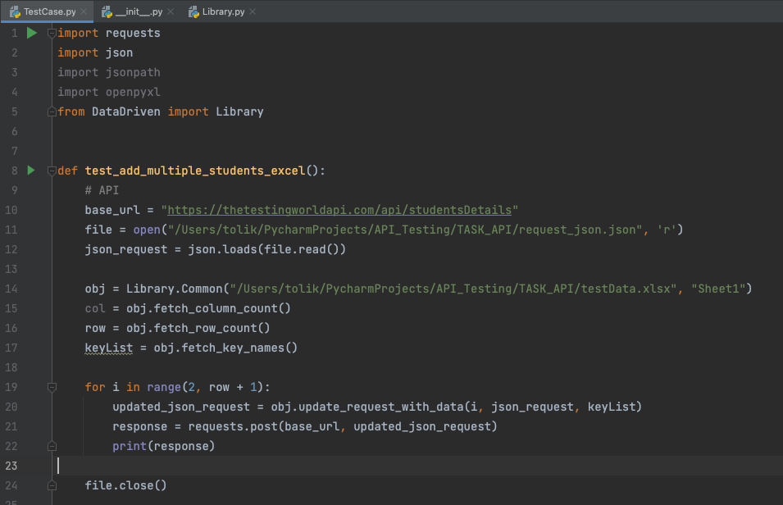

import requests  
import json  
import jsonpath  
import openpyxl  
from DataDriven import Library  
  
  
def test_add_multiple_students_excel():  
 # API  
 base_url = "https://thetestingworldapi.com/api/studentsDetails"  
 file = open("/Users/tolik/PycharmProjects/API_Testing/TASK_API/request_json.json", 'r')  
 json_request = json.loads(file.read())  
  
 obj = Library.Common("/Users/tolik/PycharmProjects/API_Testing/TASK_API/testData.xlsx", "Sheet1")  
 col = obj.fetch_column_count()  
 row = obj.fetch_row_count()  
 keyList = obj.fetch_key_names()  
  
 for i in range(2, row + 1):  
 updated_json_request = obj.update_request_with_data(i, json_request, keyList)  
 response = requests.post(base_url, updated_json_request)  
 print(response)  
  
 file.close()

Create the __init__.py file

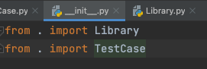

from . import Library  
from . import TestCase

[DataDriven]$ pytest TestCase.py -s

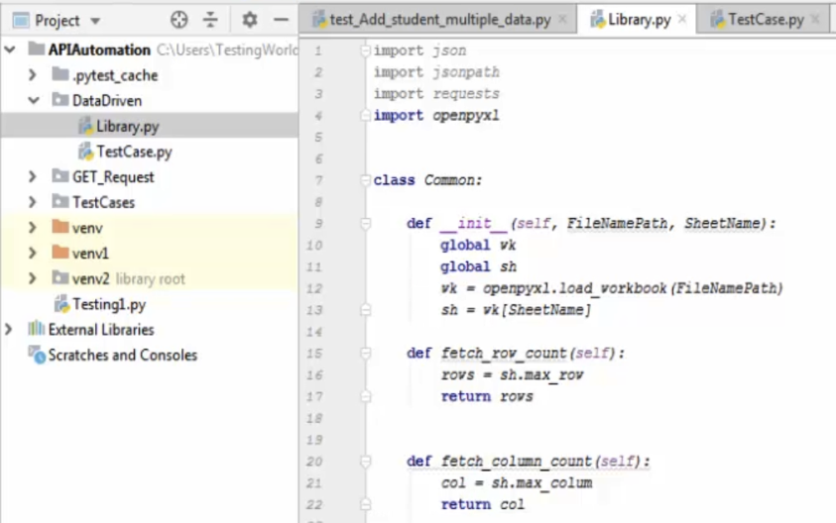

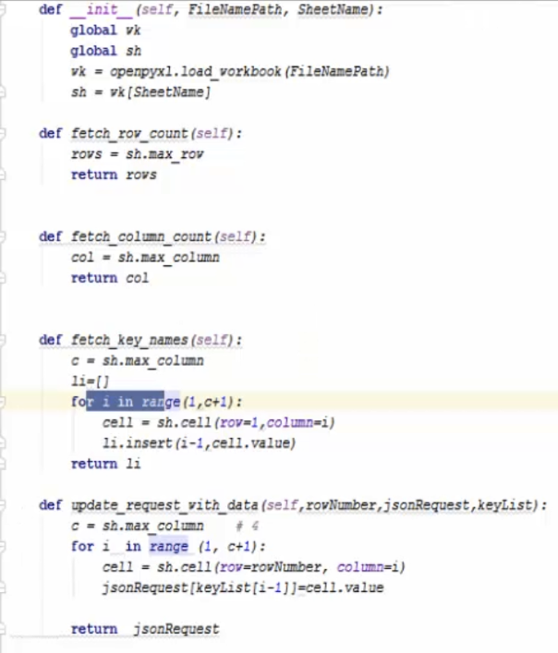

In the DataDriven folder create file => __init__.py

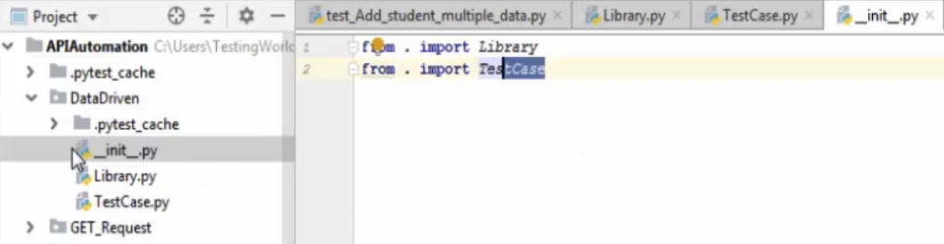

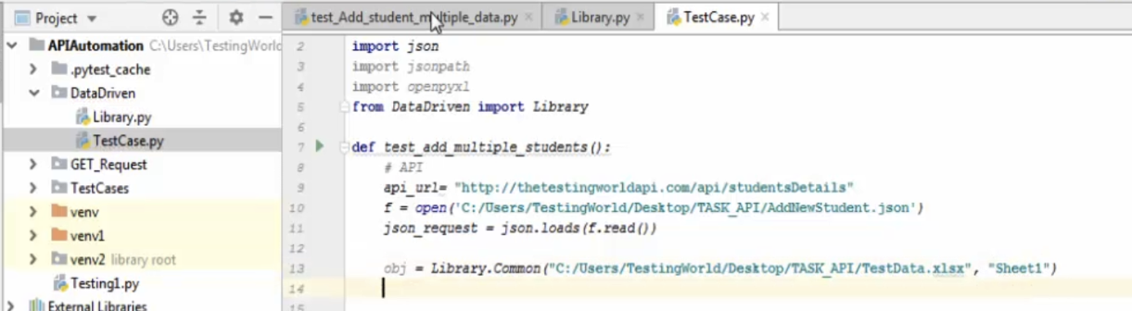

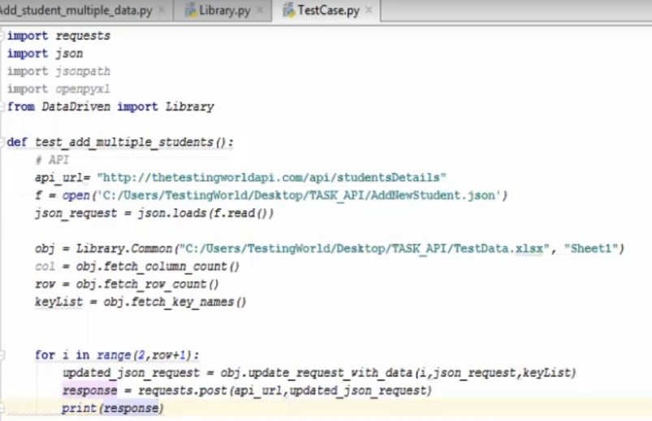

[DataDriven]$ pytest TestCase.py -s

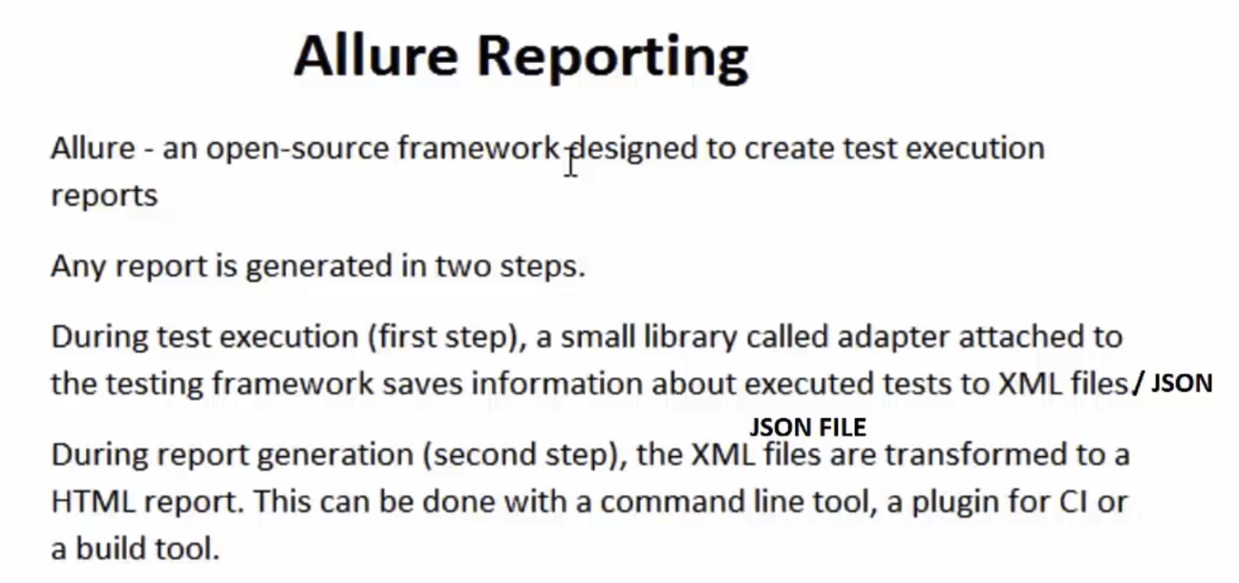

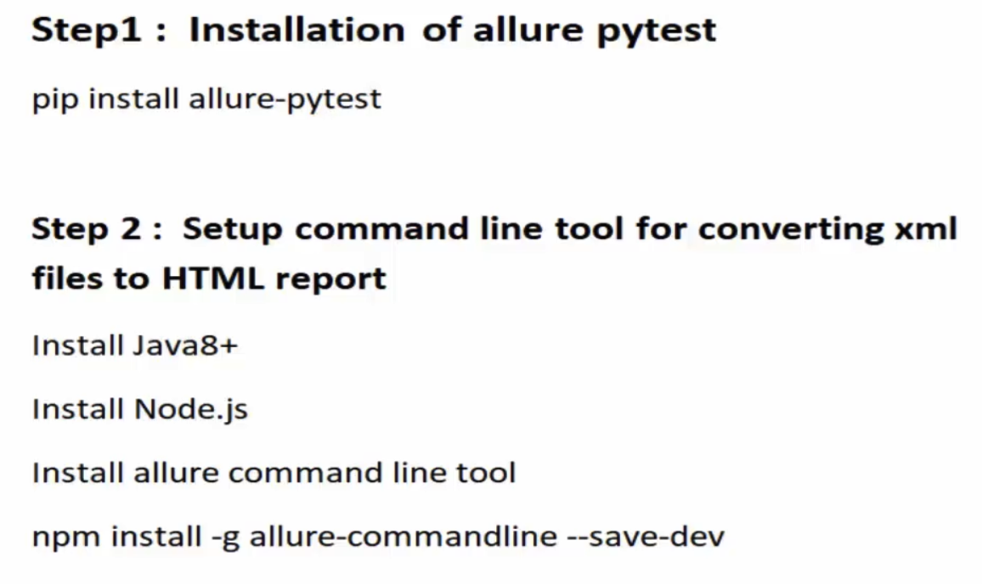

To verify that allure has been installed on your system, type $ allure

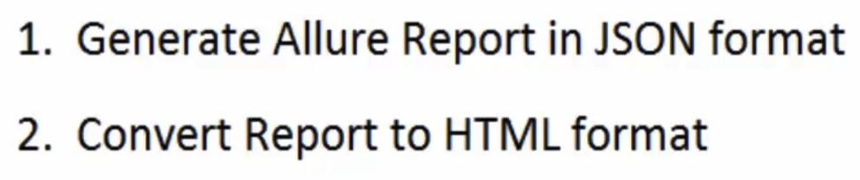

From the project root directory, create folder Reports

Run all testcases from the TestCases folder =>

[API_Testing]$ pytest --alluredir

(provide full path to directory where you want to create your report) /Users/tolik/PycharmProjects/API_Testing/Reports

(folder where testing cases located)

TestCases

$ pytest --alluredir /Users/tolik/PycharmProjects/API_Testing/Reports TestCases

Convert report into the html

$ allure serve /Users/tolik/PycharmProjects/API_Testing/Reports

Report successfully generated to /var/folders/3d/bnx3fy716rd607nk12ldr4qw0000gn/T/7662526996152091122/allure-report

★★★★★★★★★★★★★★★★★★★★★★★★



<https://thetestingworldapi.com/swagger/ui/index#!/studentsDetails/studentsDetails_PoststudentsDetail>

★★★★★★★★★★★★★★★★★★★★★★★★

1. How do you test a REST API?

2. What is a request?

3. What is a response?

4. What is the endpoint?

5. Headers

6. What is a REST API?

7. What are the characteristics of a RESTful API?

8. What is HTTP and how does it relate to REST APIs?

9. What are some best practices for securing a REST API?

10. How do you handle errors in a REST API?

11. What is the difference between a REST API and a SOAP API?

12. Parameters to be retrieved

13. What are the common HTTP methods used in REST APIs?

14. What is HATEOAS and why is it important in REST APIs?

15. What is a stateless API and why is it important?

16. What is a RESTful resource?

17. What is the difference between a REST API and a RESTful API?

18. How does REST differ from SOAP?

19. What are the different HTTP methods supported in REST and what are

they used for?

20. How do you version a REST API?

21. What is the difference between a RESTful API and a HTTP API?

22. What is a RESTful URL?

23. How do you secure a REST API?

24. What is statelessness in the context of REST APIs?

25. What are some best practices for designing a RESTful API?

⚜️ What is a REST API?

REST (Representational State Transfer) API is a software architectural style for building web services. It is a set of constraints and standards for creating web APIs, which are scalable, maintainable, and simple to consume. A REST API defines a set of operations that can be performed on resources using HTTP methods such as GET, POST, PUT, DELETE, etc. The response from the API is usually in a format such as JSON or XML, and the client-server communication happens over HTTP.

REST APIs are used in many web applications, mobile applications, and other systems to access data and services from a server, and they have become a popular choice for building APIs due to their ease of use and flexibility.

⚜️ What is a request?

A request is a message sent from a client to a server asking for information or the execution of a specific action. In the context of the World Wide Web, a request is typically sent by a web browser to a web server, asking for a specific page or resource.

In a RESTful API, a request is used to retrieve or modify data on the server. A request can contain various elements, such as a method (such as GET, POST, PUT, or DELETE), a URI (Uniform Resource Identifier), headers, and a body. The method indicates the type of action being performed on the resource, and the URI specifies the resource being requested. The headers contain additional information about the request, such as the content type and the preferred language. The body can contain data that is being sent to the server, such as form data or JSON payloads.

Once the request is received by the server, it processes the request and returns a response, which can include a status code, headers, and a body. The status code indicates the result of the request, such as success (200 OK) or failure (404 Not Found), and the body contains the requested information or data.

⚜️ What is a response?

A response is a message sent from a server to a client in response to a request. In the context of the World Wide Web, a response is typically sent by a web server to a web browser in response to a request for a specific page or resource.

In a RESTful API, a response is the data returned by the server in response to a client's request. The response includes a status code, headers, and a body. The status code indicates the result of the request, such as success (200 OK) or failure (404 Not Found), and the headers contain additional information about the response, such as the content type and the length of the response body. The body contains the requested data or information, such as a JSON or XML document.

A response is an important part of the interaction between the client and the server in a RESTful API, as it provides the requested information or the result of the requested action to the client. The structure and content of the response can affect the ability of the client to process the data and determine the next steps in the interaction.

⚜️ What is the endpoint?

An endpoint is a specific URL (Uniform Resource Locator) that represents a resource in a RESTful API. An endpoint is the endpoint of a communication between two systems and defines a specific location for accessing a resource.

In a RESTful API, endpoints define the location of a specific resource, such as a user, a product, or an order, and can be used to retrieve or manipulate that resource. For example, in a e-commerce API, you might have endpoints like /products to retrieve a list of products, /products/{id} to retrieve a specific product by its ID, /orders to retrieve a list of orders, and /orders/{id} to retrieve a specific order by its ID.

Each endpoint in a RESTful API can accept various methods, such as GET, POST, PUT, and DELETE, which indicate the type of action being performed on the resource. For example, a GET request to the /products endpoint might retrieve a list of products, while a POST request to the same endpoint might create a new product.

Endpoints are a key component of a RESTful API, as they define the resources that are available and the methods for accessing and manipulating those resources. Endpoints should be designed to be intuitive, easy to understand, and consistent across the API.

⚜️ Parameters to be retrieved

In computing, the term "params" usually refers to parameters or arguments passed to a function, method, or API (Application Programming Interface).

These parameters are values that are passed to a function or API to configure its behavior or provide additional information. For example, in an API request, the params may include values such as the resource to be retrieved, the format of the response, and any filters to apply to the data.

By passing different values as parameters, the same API can be used to perform different actions or return different results.

⚜️ Headers

Headers are a part of a request or response in a RESTful API and contain additional information about the request or response. Headers can include a variety of information, including:

- Authorization: Used to provide authentication information, such as an API key or a token.

- Content-Type: Specifies the format of the request body, such as JSON or XML.

- Accept: Specifies the format of the response body that is expected, such as JSON or XML.

- Content-Length: Specifies the length of the request body.

- User-Agent: Identifies the client software and version making the request.

- Referrer: Indicates the URL of the previous page that linked to the current page.

- Cache-Control: Specifies cache-related information, such as whether the response can be cached.

- Accept-Encoding: Specifies the encoding format, such as gzip, that can be used to compress the response.

These are just some of the common headers that can be included in a request or response in a RESTful API. The specific headers that are included can depend on the requirements of the API and the client. Headers are an important part of the request-response cycle in a RESTful API, as they provide additional information about the request or response that can be used for various purposes, such as authentication, content negotiation, and caching.

⚜️ Here's an example of a header that includes an authorization token:

Authorization: Bearer [token_value]

In this example, the header key is Authorization and the value is Bearer [token_value]. The Bearer keyword is used to indicate that the authorization is a bearer token. The [token_value] is replaced with the actual token value.

The Authorization header is used to provide authentication information for the request. In this case, the bearer token is used to identify the user or client making the request. The token is usually obtained from a previous authentication process and is sent in the header of each subsequent request to the API.

On the server side, the API will validate the token to determine the identity of the user and whether the user has the necessary permissions to access the requested resource. If the token is valid, the server will process the request and return a response. If the token is not valid, the server will return an error response.

This is just one example of how the Authorization header can be used to provide authentication information. Other types of authentication, such as basic authentication or OAuth, may use different header values or additional headers to provide authentication information.

⚜️ What are the common HTTP methods used in REST APIs?

REST APIs commonly use the following HTTP methods:

GET: used to retrieve data from the server.

POST: used to submit data to the server for processing, such as uploading a file or submitting a form.

PUT: used to update an existing resource on the server.

DELETE: used to delete a resource on the server.

PATCH: used to partially update an existing resource on the server.

These methods are used in combination with HTTP requests and responses to provide a standardized way for communication between the client and server. In REST APIs, the HTTP methods are used to determine the desired action for the requested resource, and the response from the server indicates the outcome of the request.

⚜️ What are the characteristics of a RESTful API?

A RESTful API (Representational State Transfer API) is an API that adheres to certain architectural constraints and principles. Here are the characteristics of a RESTful API:

Client-Server Architecture: RESTful APIs follow a client-server architecture, where the client makes requests to the server, and the server returns a response.

Statelessness: RESTful APIs are stateless, meaning that each request contains all the information necessary to complete the request, and no client context is stored on the server between requests.

Cacheability: RESTful APIs are cacheable, meaning that responses can be cached by the client to improve performance and reduce server load.

Layered System: RESTful APIs can be built on top of a layered system, where the client only needs to know the endpoint URL, and the intermediate layers can be used to add additional security, load balancing, or other features.

Uniform Interface: RESTful APIs have a uniform interface, where all resources are identified by a unique URI, and the same set of HTTP methods (GET, POST, PUT, DELETE, etc.) are used to manipulate resources.

Representational State Transfer: RESTful APIs transfer representations of resources, where resources are represented as documents, such as JSON or XML documents, and can be manipulated using a standard set of operations.

By adhering to these characteristics, a RESTful API provides a flexible, scalable, and maintainable way of building and consuming APIs, and can be easily consumed by a wide range of clients, including web browsers, mobile devices, and desktop applications.

⚜️ What is the difference between a REST API and a SOAP API?

REST (Representational State Transfer) and SOAP (Simple Object Access Protocol) are two different protocols for exchanging data and performing operations over the internet. Here are some key differences between REST and SOAP APIs:

Architectural Style: REST is an architectural style that uses simple and lightweight HTTP methods, while SOAP is a protocol that uses XML for its message format and is typically carried over HTTP or SMTP.

Data Format: REST APIs can use any format for data exchange, such as JSON or XML, while SOAP APIs use XML as the standard data format.

Flexibility: REST is more flexible than SOAP, as it does not enforce a specific structure or message format for data exchange. SOAP, on the other hand, has strict rules for message format and structure.

Performance: REST APIs are typically faster and use less bandwidth than SOAP APIs, as they use a lighter message format.

Security: SOAP provides more security features than REST, such as built-in support for encryption and digital signatures. REST relies on transport-level security mechanisms, such as SSL/TLS, to secure data in transit.

Use Cases: REST is more suitable for simple and fast operations, such as retrieving data or performing simple actions, while SOAP is better suited for complex operations that require a higher level of security and transactional integrity.

In conclusion, both REST and SOAP have their own strengths and weaknesses, and the choice between them depends on the specific requirements of a project. REST is a popular choice for building web APIs due to its simplicity and flexibility, while SOAP is still widely used in enterprise applications that require a higher level of security and reliability.

⚜️ How do you handle errors in a REST API?

Handling errors in a REST API involves returning appropriate error codes and messages to the client when an error occurs during an API operation. Here are some best practices for handling errors in a REST API:

Use HTTP response codes: Use standard HTTP response codes, such as 404 Not Found, 401 Unauthorized, and 500 Internal Server Error, to indicate the status of API operations and any errors that may occur.

Return error messages: Return a clear and concise error message in the response body that describes the error and provides helpful information for resolving the issue.

Provide specific error codes: Provide specific error codes for each type of error that can occur in the API. This can help the client understand the nature of the error and take appropriate action.

Log errors: Keep detailed logs of all errors that occur in the API, including a stack trace, so that you can easily identify and debug the source of the error.

Avoid exposing sensitive information: Avoid exposing sensitive information in error messages, such as passwords or database details, to prevent against security breaches.

Test error handling: Test the API thoroughly to ensure that it correctly handles all possible error scenarios and returns appropriate error codes and messages.

By following these best practices, you can ensure that errors in a REST API are handled effectively, and that the API provides helpful and informative error responses to the client.

⚜️ What are some best practices for securing a REST API?

Securing a REST API involves protecting it against various security threats such as unauthorized access, data breaches, and malicious attacks. Here are some best practices to secure a REST API:

Authentication: Implement proper authentication mechanisms such as OAuth, JWT, or API keys to ensure that only authorized users can access the API.

SSL/TLS: Use SSL/TLS encryption to secure the communication between the client and server and protect sensitive data in transit.

Authorization: Implement proper authorization mechanisms to ensure that users can only perform actions that they are authorized to do.

Input Validation: Validate all incoming requests to ensure that they conform to the expected format and do not contain any malicious payloads.

Output Encoding: Properly encode all output data to prevent against cross-site scripting (XSS) attacks.

Logging and Monitoring: Keep detailed logs of API activity, and monitor the logs for any suspicious activity that may indicate a security threat.

Regular Patching and Updating: Regularly patch and update the underlying technology stack, including the operating system, web server, and framework, to fix any known vulnerabilities.

Document the Security Model: Clearly document the security model for the API, including how authentication and authorization are performed, so that users and developers can understand the security implications of using the API.

Implementing these best practices can help ensure the security of a REST API and protect against common security threats.

⚜️ How do you test a REST API?

There are several approaches to testing a REST API:

Manual Testing: Testing the API manually using a tool like Postman or cURL to send requests and observe the response.

Automated Testing: Writing automated test cases using a testing framework like JUnit, TestNG, or Postman. These test cases can be run as part of the continuous integration process.

Load Testing: Testing the API under heavy load to see how it performs and identify any performance bottlenecks.

Security Testing: Testing the API for potential security vulnerabilities like SQL injection, cross-site scripting, and other malicious attacks.

Functional Testing: Verifying that the API works as expected by testing its various functionalities.

Integration Testing: Testing the API in the context of the larger system to see how it integrates with other components.

It is recommended to use a combination of manual and automated testing, and to test the API at different stages of development to catch any issues early on.

⚜️ What is HTTP and how does it relate to REST APIs?

HTTP (Hypertext Transfer Protocol) is a protocol for transmitting data over the internet. It is the foundation of data communication for the World Wide Web and is based on a request-response model.

In the context of REST APIs, HTTP is used as the protocol for transmitting requests and responses between the client and server. REST APIs use standard HTTP methods such as GET, POST, PUT, DELETE, etc. to perform operations on resources, and HTTP response codes such as 200 OK, 404 Not Found, 401 Unauthorized, etc. to indicate the status of these operations.

The combination of HTTP and REST provides a simple and flexible way for applications to exchange data and perform actions over the internet. The use of standard HTTP methods and response codes makes REST APIs easily understandable and accessible to a wide range of clients and technologies.

⚜️ What is the difference between a REST API and a SOAP API?

REST (Representational State Transfer) and SOAP (Simple Object Access Protocol) are two different protocols for exchanging data and performing operations over the internet. Here are some key differences between REST and SOAP APIs:

Architectural Style: REST is an architectural style that uses simple and lightweight HTTP methods, while SOAP is a protocol that uses XML for its message format and is typically carried over HTTP or SMTP.

Data Format: REST APIs can use any format for data exchange, such as JSON or XML, while SOAP APIs use XML as the standard data format.

Flexibility: REST is more flexible than SOAP, as it does not enforce a specific structure or message format for data exchange. SOAP, on the other hand, has strict rules for message format and structure.

Performance: REST APIs are typically faster and use less bandwidth than SOAP APIs, as they use a lighter message format.

Security: SOAP provides more security features than REST, such as built-in support for encryption and digital signatures. REST relies on transport-level security mechanisms, such as SSL/TLS, to secure data in transit.

Use Cases: REST is more suitable for simple and fast operations, such as retrieving data or performing simple actions, while SOAP is better suited for complex operations that require a higher level of security and transactional integrity.

In conclusion, both REST and SOAP have their own strengths and weaknesses, and the choice between them depends on the specific requirements of a project. REST is a popular choice for building web APIs due to its simplicity and flexibility, while SOAP is still widely used in enterprise applications that require a higher level of security and reliability.

⚜️ What is HATEOAS and why is it important in REST APIs?

HATEOAS stands for Hypermedia as the Engine of Application State. It is a principle of RESTful web services that states that a client interacts with a REST API entirely through the representations returned from the server. These representations include hypermedia links that allow the client to dynamically discover new actions and resources, without any prior knowledge of the API's structure or behavior.

HATEOAS is important in REST APIs because it provides a flexible and decoupled way for client-server communication. The client is not required to know the structure of the API ahead of time or hard-code the URLs for each resource. Instead, the client can follow the hypermedia links in the representations returned from the server to discover new resources and actions as needed. This allows for a more dynamic and adaptable system, as the server can change the structure of the API or add new resources without breaking existing client applications.

In summary, HATEOAS is important in REST APIs because it allows for a more flexible, scalable, and adaptable way for client-server communication, by allowing the client to dynamically discover new resources and actions.

⚜️ What is a stateless API and why is it important?

A stateless API is an API that does not maintain client state information on the server between requests. This means that each request from the client must contain all of the information necessary for the server to fulfill the request, without relying on any stored context or previous request history.

Statelessness is important for a number of reasons:

Scalability: Stateless APIs can be easily scaled horizontally, as there is no shared state to manage across multiple servers. This makes it possible to add more servers to handle increased load, without having to worry about coordination and consistency between servers.

Simplicity: Stateless APIs are typically simpler to implement, as they do not require the server to manage state or track the state of individual clients. This can lead to more reliable and easier-to-maintain systems.

Portability: Because stateless APIs do not maintain client state, they can be easily moved between servers or environments without having to worry about preserving state information.

Interoperability: Stateless APIs can be easily integrated into other systems, as they do not rely on any shared context or prior request history.

In summary, statelessness is an important characteristic of REST APIs, as it allows for greater scalability, simplicity, portability, and interoperability. It is also one of the key principles of RESTful architecture.

⚜️ What is a RESTful resource?

A RESTful resource is a fundamental concept in REST (Representational State Transfer) architecture, which is a style of software architecture for distributed systems such as the World Wide Web. In REST, resources are entities that can be manipulated or accessed through the API, such as a user, a product, or a customer order.

A RESTful resource is defined by its URI (Uniform Resource Identifier), which is a unique string that identifies the resource and distinguishes it from other resources. The URI is used to access and manipulate the resource through the API, using HTTP methods such as GET, POST, PUT, DELETE, and others.

A RESTful resource should also have a well-defined representation, which is a representation of the resource's state, such as its data and metadata, in a specific format such as JSON or XML. The representation of a resource is returned by the API in response to a request, and is used by the client to interact with the resource.

In summary, a RESTful resource is a fundamental concept in REST architecture, representing an entity that can be accessed and manipulated through the API, and is defined by its URI and representation.

⚜️ What is the difference between a REST API and a RESTful API?

The terms "REST API" and "RESTful API" are often used interchangeably, but they have slightly different meanings.

A REST API (or simply REST) is a set of guidelines and constraints for creating a web-based software architecture that uses HTTP requests to access and manipulate resources. REST is an architectural style for building distributed systems, and is not tied to any specific technology or programming language.

A RESTful API, on the other hand, is an API that follows the REST architectural style and constraints. It is an implementation of a REST API that adheres to the principles of REST, such as being stateless, having a client-server architecture, and using HTTP methods to manipulate resources.

In other words, a RESTful API is a type of REST API that follows the REST architectural style and principles, and provides a consistent, standardized way for accessing and manipulating resources.

In conclusion, all RESTful APIs are REST APIs, but not all REST APIs are RESTful APIs, as they may not fully adhere to the constraints and principles of REST.

⚜️ How does REST differ from SOAP?

REST (Representational State Transfer) and SOAP (Simple Object Access Protocol) are two different protocols for exchanging data over the Internet. Although both are used for web services, they have significant differences in terms of their design, functionality, and intended use.

Design: REST is an architectural style that uses a stateless, client-server model, and a uniform interface for accessing resources, while SOAP is a protocol that specifies the format and rules for exchanging structured data in the implementation of web services. REST is typically built on top of HTTP, while SOAP can use a variety of transport protocols such as HTTP, SMTP, or TCP.

Functionality: REST is typically used for lightweight, data-driven applications that have a lower latency requirement, while SOAP is designed to handle more complex use cases that involve multiple data sources, transactions, and security. REST provides less functionality than SOAP, as it focuses on simplicity and scalability, while SOAP provides more functionality and is more suitable for enterprise-level applications.

Format: REST uses simple, text-based formats such as JSON and XML for data exchange, while SOAP uses a complex XML format that requires more processing power and network bandwidth. REST also uses fewer data types than SOAP, and its payloads are typically smaller and faster to process.

In conclusion, REST and SOAP are two different protocols that are used for exchanging data over the Internet, and each has its own strengths and weaknesses. REST is typically used for lightweight, data-driven applications, while SOAP is more suitable for enterprise-level applications that require more functionality and security.

⚜️ What are the different HTTP methods supported in REST and what are they used for?

REST (Representational State Transfer) uses HTTP (Hypertext Transfer Protocol) methods to access and manipulate resources. The following are the most common HTTP methods used in REST:

GET: This method is used to retrieve a representation of a resource. It is a safe and idempotent method, meaning that multiple identical GET requests should produce the same result and have no side effects.

POST: This method is used to submit data to the resource identified by the URI, such as creating a new resource. It is not safe and is not idempotent, meaning that repeated POST requests may result in multiple resources being created.

PUT: This method is used to update an existing resource or create a new resource if it does not exist. It is idempotent, meaning that multiple identical PUT requests should produce the same result.

DELETE: This method is used to delete a resource identified by the URI. It is idempotent, meaning that multiple identical DELETE requests should produce the same result.

HEAD: This method is used to retrieve only the headers of a resource representation, without the actual data. It is safe and idempotent.

OPTIONS: This method is used to describe the communication options for the resource identified by the URI. It is safe and idempotent.

PATCH: This method is used to apply partial updates to a resource. It is not safe and is not idempotent.

These HTTP methods are used in REST to perform operations on resources, such as retrieving, creating, updating, and deleting resources. The methods are selected based on the type of operation that needs to be performed on the resource, and the specific constraints and requirements of the application.

⚜️ How do you version a REST API?

There are several strategies for versioning a REST API:

URL versioning: This involves including the version number in the URL of the API endpoint, such as /api/v1/resources. This makes it clear which version of the API is being accessed, and allows multiple versions of the API to be maintained and accessed simultaneously.

Query parameter versioning: This involves including the version number as a query parameter in the URL, such as /api/resources?version=1. This approach is similar to URL versioning, but the version number is included in the query string rather than in the URL path.

Header versioning: This involves using a custom HTTP header, such as X-API-Version, to indicate the version of the API being accessed. This approach allows the API version to be specified in the request header, rather than in the URL or query string.

Accept header versioning: This involves using the HTTP Accept header to specify the version of the API being accessed. This approach allows the client to request a specific version of the API by including an Accept header in the request, such as Accept: application/vnd.api+json;version=1.

Each of these strategies has its own advantages and disadvantages, and the best approach depends on the specific requirements and constraints of the API. In general, URL versioning is the simplest and most straightforward approach, while header versioning and Accept header versioning allow for more flexible and scalable versioning.

It is important to note that when versioning an API, it is important to ensure that backward compatibility is maintained, so that existing clients are not affected by changes in the API. This requires careful planning and testing to ensure that changes to the API are made in a way that does not break existing clients.

⚜️ What is the difference between a RESTful API and a HTTP API?

A RESTful API (Representational State Transfer API) is a type of API that adheres to the principles of REST architecture. This means that it uses HTTP methods (such as GET, POST, PUT, DELETE, etc.) to access and manipulate resources, and uses HTTP status codes to indicate success or failure of operations. RESTful APIs also make use of hypermedia (such as HATEOAS) to allow clients to navigate the API and discover related resources.

A HTTP API, on the other hand, is simply an API that uses HTTP as the communication protocol. It may or may not adhere to the principles of REST architecture, and may use HTTP methods and status codes in different ways.

In other words, all RESTful APIs are HTTP APIs, but not all HTTP APIs are RESTful APIs. A RESTful API is a specific type of HTTP API that adheres to the principles of REST, while a HTTP API is a more general term that encompasses both RESTful and non-RESTful APIs.

The main difference between the two is that a RESTful API follows a specific architectural style and uses specific HTTP methods and status codes in a standardized way, while a HTTP API may use HTTP in any way it sees fit. RESTful APIs are typically more structured and easier to understand, while HTTP APIs may be more flexible and allow for more customization.

⚜️ What is a RESTful URL?

A RESTful URL (or resource identifier) is a unique identifier for a specific resource within a RESTful API. It is used to access and manipulate that resource, and typically follows a predictable pattern that includes the resource name, any necessary parameters, and a unique identifier for the resource itself.

A RESTful URL should be easy to understand and use, and should provide a clear mapping between the URL and the underlying resource. It should also be self-describing, allowing clients to determine the type and structure of the resource being accessed simply by examining the URL.

For example, consider a RESTful API for a blog platform that has a resource for articles.

The RESTful URL for an article with the ID 123 might be something like:

/articles/123

This URL clearly identifies the resource being accessed (an article), and includes a unique identifier for the article (123). Clients can use this URL to retrieve information about the article, update the article, delete the article, and perform other operations on the article.

It's important to note that RESTful URLs should be predictable and consistent, to make it easy for clients to access and manipulate resources within the API. The exact format of the URLs will depend on the specific requirements of the API and the resources it exposes, but should follow the principles of RESTful architecture and provide a clear mapping between URLs and resources.

⚜️ How do you secure a REST API?

There are several ways to secure a REST API, including:

Token-based authentication: This involves the client sending a token with each request, which the server uses to verify the identity of the client. The token can be obtained by the client by providing valid credentials to a separate authentication endpoint. This is a common approach for securing REST APIs, as it allows for stateless authentication, where the server does not need to maintain any information about the client between requests.

OAuth 2.0: This is a popular open-standard for authorization that allows clients to access resources on behalf of a resource owner. OAuth 2.0 provides a secure mechanism for allowing clients to access resources without having to send the resource owner's credentials with each request. Instead, the resource owner provides authorization to the client, which can then access resources on the resource owner's behalf using an access token.

SSL/TLS encryption: This involves using encryption to secure communication between the client and the server. SSL (Secure Sockets Layer) and TLS (Transport Layer Security) are the most commonly used protocols for securing web traffic. By using encryption, it is much more difficult for attackers to intercept and steal sensitive information, such as passwords and credit card numbers.

Input validation: This involves validating all incoming data to ensure that it is in the expected format and does not contain any malicious content. This is important for protecting the server from potential security vulnerabilities, such as SQL injection and cross-site scripting (XSS) attacks.

Access control: This involves implementing access controls to restrict which clients can access which resources. Access controls can be based on various factors, such as the client's IP address, the client's role or permissions, and the type of request being made.

It is important to note that securing a REST API requires a multi-layered approach, as no single security measure can provide complete protection against all potential threats. A combination of the above techniques, along with regular security testing and updates, is the best way to ensure the security of a REST API.

⚜️ What is statelessness in the context of REST APIs?

In the context of REST APIs, statelessness refers to the property of an API where each request to the API contains all the information necessary to complete the request, and the server does not maintain any client context between requests. This means that the server does not store any information about the client's state or previous requests, and each request is processed independently.

Statelessness is an important aspect of REST API design because it enables greater scalability, reliability, and maintainability of the API. By not maintaining client state on the server, the server can handle a larger number of requests and can more easily be scaled to handle increased traffic. Additionally, statelessness reduces the risk of errors and bugs, as the server does not need to manage complex state information or manage multiple client connections.

In practice, statelessness is achieved through the use of token-based authentication, where the client includes an authentication token with each request to the API. This token contains all the information necessary to verify the client's identity, and the server can use this information to determine whether the client is authorized to access the requested resource.

It's important to note that statelessness should be balanced against the need for security and functionality, as there may be certain cases where some level of client state is necessary. In these cases, it's important to carefully design and implement the state management mechanism to ensure it is secure, scalable, and reliable.

⚜️ What are some best practices for designing a RESTful API?

Use HTTP methods appropriately: Each HTTP method (e.g. GET, POST, PUT, DELETE) should be used for its intended purpose. For example, use the GET method to retrieve resources and the POST method to create new resources.

Use HTTP status codes correctly: HTTP status codes provide information about the result of a request. It's important to use the correct status code for each response, for example, 200 OK for a successful request, 404 Not Found for a resource that cannot be found, and 500 Internal Server Error for a server-side error.

Design resources using nouns: Resources should be designed using nouns, not verbs, and should be named using plural nouns. For example, use /users instead of /get-users.

Use HATEOAS: HATEOAS (Hypermedia as the Engine of Application State) is a constraint of the REST architecture that requires that the client be able to discover the available actions for a resource through the API response. This makes the API easier to use and helps to prevent tight coupling between the client and server.

Use a consistent URL structure: URLs should be structured consistently and should clearly indicate the structure of the API. For example, use /users/{userId} to represent a specific user resource.

Support filtering, sorting, and pagination: Provide support for filtering, sorting, and pagination of resources to make it easier for clients to work with large collections of resources.

Use appropriate HTTP response codes: Use HTTP response codes to indicate success or failure of a request, such as 200 OK for a successful request and 400 Bad Request for a request that cannot be processed.

Support flexible response formats: The API should support multiple response formats, such as JSON and XML, to accommodate the needs of different clients.

Version your API: Versioning helps ensure that changes to the API do not break existing clients, and provides a mechanism for supporting multiple versions of the API.

Document the API: It's important to provide clear and detailed documentation for the API, including information about available resources, request and response formats, and error codes. This helps ensure that clients are able to effectively use the API.

By following these best practices, you can design a RESTful API that is scalable, maintainable, and easy to use.